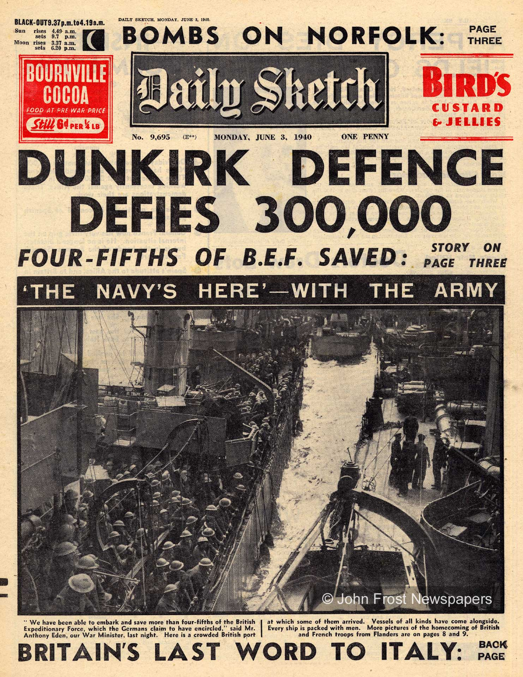
Primary Source Analysis
Evacuation of Dunkirk

Questions:
- Looking at the image, headings and quotes what can you gather from analysing this primary source about the Battle and evacuation of Dunkirk?

- Explain how this is a positive or a negative front page for the British public?

- Apart from information about Dunkirk, Italy and the bombs on Norfolk what else does the Daily Sketch feel is important to remind the public about on their front page?

