Winston Churchill’s
“We shall fight ‘them’ on the beaches” speech
June 4th 1940

At 5:30 a.m. on May 10, 1940, Nazi Germany began a massive attack against Holland, Belgium, Luxembourg, and France. Defending those countries were soldiers of the British Expeditionary Force along with the French, Belgian, and Dutch (Allied) armies.
The Germans relied on an aggressive battle plan, utilizing modern communications such as radio to direct troops in the field. The Allies, for their part, assumed a defensive posture, just as they had done at the start of World War I, and in many cases still relied on hand-delivered messages.
As a result, the German Blitzkrieg (lightning attack) caught the Allies off-guard. German Panzer tanks staged a surprise attack through the 'impassable' Ardennes Forest then turned northward and soon surrounded the bulk of the Allied armies in Belgium. The "Miracle at Dunkirk" occurred next as 350,000 British and French soldiers were hurriedly evacuated from the coastline by Royal Navy ships and a flotilla of civilian boats of every shape and size.
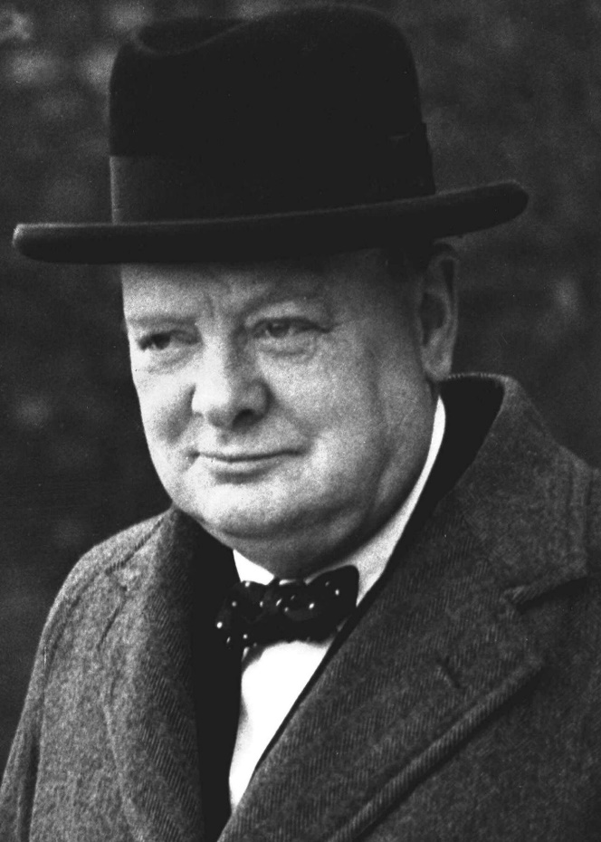

After just a few weeks of battle, Hitler's armies had conquered Holland, Luxembourg and Belgium. Paris fell on June 14th. Three days later, the French requested an armistice.
The following day, June 18th, British Prime Minister Winston Churchill spoke to the House of Commons about the disastrous turn of events in Europe amid the stark realization that Britain now stood alone against the seemingly unstoppable might of Hitler's military machine.

“I have, myself, full confidence that if all do their duty, if nothing is neglected, and if the best arrangements are made, as they are being made, we shall prove ourselves once more able to defend our island home, to ride out the storm of war, and to outlive the menace of tyranny, if necessary for years, if necessary alone.
We shall go on to the end. We shall fight in France, we shall fight on the seas and oceans, we shall fight with growing confidence and growing strength in the air, we shall defend our island, whatever the cost may be. We shall fight on the beaches, we shall fight on the landing grounds, we shall fight in the fields and in the streets, we shall fight in the hills; we shall never surrender.
And if, which I do not for a moment believe, this island or a large part of it were subjugated and starving, then our Empire beyond the seas, armed and guarded by the British Fleet, would carry on the struggle, until, in God's good time, the New World, with all its power and might, steps forth to the rescue and the liberation of the old.”

