*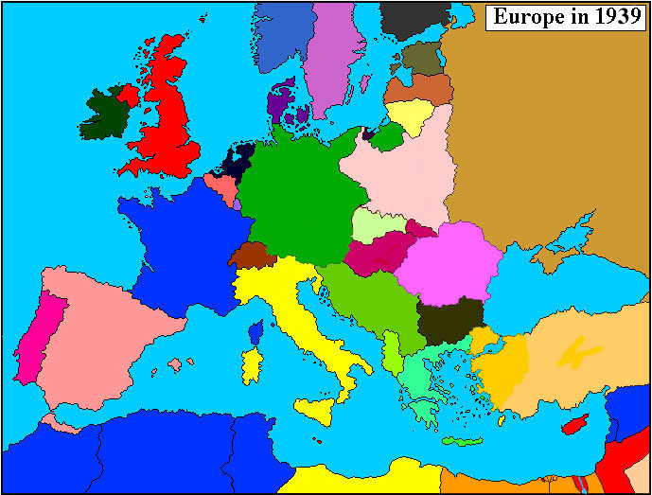Europe 1939*

*Germany*

*Italy*

*Hungary*

*Latvia*

*Estonia*

*Yugoslavia*

*Romania*

*Bulgaria*

*Spain*

*Italian Libya*

*Norway*

*Sweden*

*Denmark*

*Netherlands*

*Belgium*

*Luxemburg*

*Albania*

*French*

*French Algeria*

*French Tunisia*

*Russia*

*Free City of Danzig*

*Poland*

*Bulgaria*

*Portugal*

*Egypt*

*Palestine Mandate*

*Malta*

*Greece*

*Lithuania*

*Trans-Jordan Kingdom*

*Switzerland*

*Slovakia*

*United Kingdom*

*Ireland*

*Turkey*

*French Syria*

*Finland*

*Morocco*